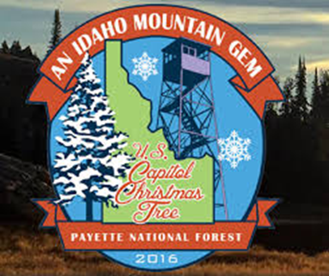
The U.S. Capitol Christmas Tree
is Coming to Alturas!!
We are so excited to be a part of this year’s tour. Alturas has been asked to help by providing refreshments during the celebration.
We anticipate a large crowd of up to 500 people.

The PTT is providing hot cocoa and we are asking each family to consider donating one dozen STORE BOUGHT cookies.

Please bring your cookies in to the school
THURSDAY, November 10th.

THANK YOU FOR YOUR SUPPORT!!

